Income Averaging- Creating More Housing Now!

With the goal of working towards the creation of Industry Standards, Dominium is proud to share much of what we have learned about income averaging through discussions with industry experts in a series of topic-based correspondence that is meant to be shared with all interested industry professionals. We hope that through the sharing of this content, we can encourage the industry to work together to create widely accepted practices of how to utilize income averaging in a way that is both consistent and marketable.

ARTICLE 2: THE COMPELLING WHY

In last week's article, we discussed what Jen Brewerton, the Vice President of Compliance here at Dominium, is calling "The Cliff." The Cliff is a misconception that if one unit within an income averaging property goes out of compliance, you no longer meet the minimum set aside, and lose ALL of your tax credits. To summarize Jen's message- there is no Cliff.

Building off Jen's messaging on how to implement income averaging, we felt it would be helpful to share some reasons why we as an industry should maximize this new tool to its fullest potential.

Income Averaging creates More Housing NOW!

Recently, Dominium worked to explore the benefits of income averaging through the concept of studying 'capture rates' on a potential development. A capture rate is calculated by dividing the total number of units at the property by the number of age and income qualified renter households in the primary market area (PMA), or the geographic area that a proposed or existing housing community serves.

In this specific example, Novogradac and Company was engaged to prepare a market study with two separate scenarios for a 200-unit, age-restricted property. The first scenario assumed that the property would be 100% rent and income restricted at the 60% AMI level. Under this example, the market study concluded that the capture rate would be 94%. In other words, for this 200-unit development, the PMA contained 213 qualified age and income restricted households. While many believe that the demand for housing is so great that projects are pulling in renters from outside of their current PMAs, a capture rate at this level creates additional hurdles for lenders and investors.

Next, the report went on to analyze the property under the assumption that it would utilize income averaging. Under this scenario, the property included units ranging from 30% to 80% AMI, with an average at that same 60% level in the previous example. As a result, the capture rate dropped from 94% to 27%, increasing the number of qualified households within the PMA by nearly 350%.

This example demonstrates one of the primary benefits of the new program by more than tripling the amount of people that this project could benefit, while decreasing the perceived market risk at the same time. This tool will allow significantly more developments the opportunity to create mixed-income communities by generating housing that will serve residents with a wide range of incomes. The mixed-income philosophy continues to be a goal of many housing agencies and local municipalities, helping to increase socioeconomic diversity while combating NIMBYism at the same time.

Finally, this new resource effectively creates an additional form of private subsidy that has never been available before. The "Missing Middle" renters at the 60% to 80% of AMI levels are not only seeing the benefit of finding quality housing that is increasingly difficult to obtain but are doing so in a way that can generate significantly more housing for the extremely low-income populations at absolutely zero additional cost to the local, state, or federal governments.

Keeping the many benefits in mind, we urge all jurisdictions to use this new incredible tool and not attempt to limit its ability to serve increasingly cost burdened families. While many states are beginning to embrace Income Averaging, they are also creating policies that have the ability to limit its potential. One example that is gaining popularity is the concept that if Income Averaging is selected for the minimum set-aside test, then the average incomes cannot exceed a level that is less than the federally allowed 60% AMI (maximum of 58% of the AMI for example). Using the same 200-unit project mentioned above, the difference between average rents at the 58% AMI level compared to the 60% AMI level results in over $1.15 million in lost debt proceeds.

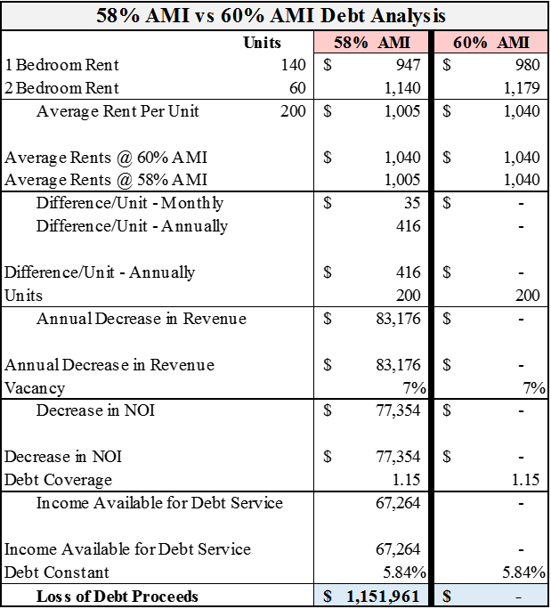

With this loss in proceeds, Income Averaging will no longer be feasible, and the development will need to return to being restricted entirely at the 60% of AMI level. This will effectively eliminate the ability to provide housing for those most in need on this project, and countless other developments that may find themselves in similar scenarios.

While this is only one example of how Income Averaging is being restricted, it highlights the importance of working together as an industry to create uniform and marketable practices that allow the most housing options for the communities we serve. This tool can help to reduce market risk and NIMBYism while generating more housing units and diversity for those most in need. All of these tools are available with absolutely no additional public subsidy and only require the check of a simple box (IRS form 8609) along with additional industry support.

Please feel free to share this information with others within the industry so we can continue to help make Income Averaging as effective as possible on a national scale. If you would like to discuss Income Averaging please do not hesitate to reach out at
incomeaveraging@dominiuminc.com.

Thank you!

2905 Northwest Blvd. Suite 150 | Plymouth, MN, 55441

